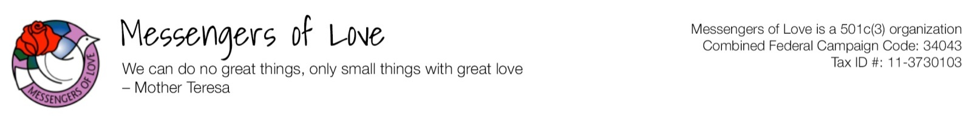
Application
Summer 2020 English Teaching and Cultural Exchange Program
(Application deadline is May 30, 2020)

1) Please fill in all fields and email this form to executive.director@messengersoflove.com.
2) Please scan your government issued identification, passport and include them with application.

Name: | Click here to enter text. | Email: | Click here to enter text.
Occupation: | Click here to enter text. | Phone: | Click here to enter text.
Address: | Click here to enter text. | City, State, Zip: |  | Click here to enter text.

☐ Male ☐Female

Are you a US citizen or Permanent Resident (Green Card)? ☐Yes ☐No
Do you have a valid passport? ☐Yes ☐No

Please select you age range:

☐18-20 ☐21-31 ☐32-41 ☐42-51 ☐52-61 ☐62-71 ☐72-81

Are you fluent in English both in speaking and writing? ☐Yes ☐No
Have you ever been convicted of a crime? ☐Yes ☐No
Have you ever worked with underage children before? ☐Yes ☐No
If yes, in what capacity?
Click here to enter text. New lines will form as needed.

Do you have any teaching experience? ☐Yes ☐No
If yes, in what subjects?
Click here to enter text. New lines will form as needed.

Please list any relevant degrees or credentials.
Click here to enter text. New lines will form as needed.

Please provide a short paragraph on why you are interested in this program and what you wish to accomplish by volunteering for this program.
Click here to enter text. New lines will form as needed..

Click here to enter text. New lines will form as needed..

Click here to enter text. New lines will form as needed..

Are you interested in volunteering for the first 3-week or second 3-week session or both? ☐First 3-week ☐Second 3-week ☐Both sessions

For those eligible, we give grant to be applied toward the airline ticket ($500 for those who volunteer for 6-week or $300 for one 3-week session). Will you be applying for the grant toward your airline ticket? ☐Yes ☐No (Please click here to apply and for more details on eligibility.)

Please provide contact information of two references:

REFERENCE 1

Name: | Click here to enter text. | Email: | Click here to enter text.

Affiliation: | Click here to enter text. | Phone: | Click here to enter text.

REFERENCE 2

Name: | Click here to enter text. | Email: | Click here to enter text.

Affiliation: | Click here to enter text. | Phone: | Click here to enter text.

I verify that all statements in this application are true to the best of my knowledge.
Signature: | Click here to enter text. | Date: | Click here to enter text.

For applicants under 21, please include parental consent form provided from link below.

You can download a Parental Consent form here.

Thank you for your interest. Application deadline is May 30, 2020

